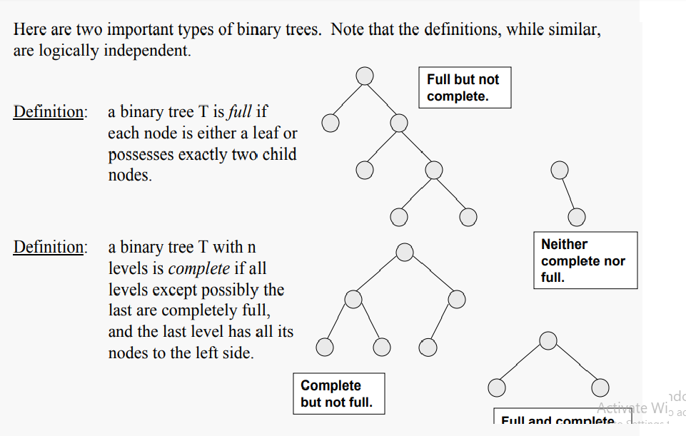

**Full Binary Tree** A Binary Tree is full if every node has 0 or 2 children. Following are examples of a full binary tree. We can also say a full binary tree is a binary tree in which all nodes except leaves have two children.

18

/ \

15 30

/ \ / \

40 50 100 40

18

/ \

15 20

/ \

40 50

/ \

30 50

18

/ \

40 30

/ \

100 40

***in a Full Binary, number of leaf nodes is number of internal nodes plus 1***  
       L = I + 1  
Where L = Number of leaf nodes, I = Number of internal nodes

A Binary Tree is **complete Binary** Tree if all levels are completely filled except possibly the last level and the last level has all keys as left as possible

Following are examples of Complete Binary Trees

18

/ \

15 30

/ \ / \

40 50 100 40

18

/ \

15 30

/ \ / \

40 50 100 40

/ \ /

8 7 9 //last level possibly left://  Complete Binary Tree is [Binary Heap](http://quiz.geeksforgeeks.org/binary-heap/).